**Bad Data Visualization**

**Objective:**To identify a misleading data visualization, analyze the elements that contribute to its deceptive nature, recreate the original chart to illustrate the flaws, and develop a corrected version that accurately represents the data—thereby enhancing critical thinking and data literacy skills.

I found a bar chart online that showed the relationship between sales and order date/market, which I found to be misleading. I used Tableau to recreate the visualization in a way that presents the data more effectively.

**Misleading Bar Chart**

Bar charts are excellent for comparing values, but when used incorrectly, they can totally lead to a different story. Now look at these misleading bar charts that look like:

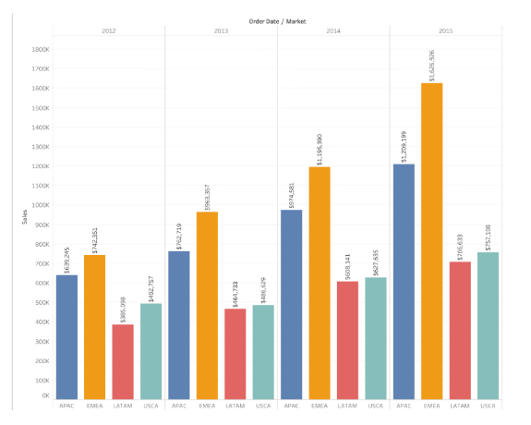

**What is wrong here?**

Bar charts can be misleading when their axes are manipulated to exaggerate or minimize value differences. For instance, if the Y-axis starts at a number other than zero, even minor differences can seem significant.

Additionally, inconsistent widths or spacing of the bars can confuse viewers. Whether these tactics appear deliberate or careless, they result in misunderstandings.

**How to Avoid It:**

* Always start the Y-axis at zero for bar charts to reflect accurate proportions.
* Keep bar widths consistent and use even spacing.
* Ensure colors and labels are clear so there’s no room for misinterpretation.

And this is how the correct bar chart visualization should look like:

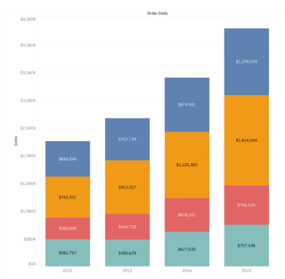

**Summary:**

This task involved identifying and analyzing a misleading bar chart that misrepresented the relationship between sales and order date/market. The original chart exaggerated value differences by manipulating the Y-axis and using inconsistent bar widths, which distorted the viewer's understanding of the data. Using Tableau, a corrected version of the chart was created to more accurately represent the information. Key principles for improving data visualization were applied, such as starting the Y-axis at zero, maintaining consistent bar widths and spacing, and ensuring clarity in colors and labels. This exercise emphasized the importance of ethical data representation and helped enhance data literacy and critical thinking skills.